NEW POINTS ON THE GRAPH y^{x} = x^{y}
Thanks to Marcelo Arruda from BRAZIL for the following ideas.
Using the basic form of De Moivre’s theorem: if $z=rcisθ=\left(\cos{θ}+i\sin{θ}\right)$ then:$z^{n}=r^{n}cisnθ=r^{n}\left(\cos{nθ}+i\sin{nθ}\right)$, so if z is to be REAL then
$\sin{nθ}$ must be zero so θ = nπ (ie multiples of π rads or 180⁰)
Therefore if $z$ is to be real then $z^{n}=r^{n}\left(\cos{nπ}+i\sin{nπ}\right)$

Then, considering two negative real numbers “a” and “b”, (N.B. the modulus is always positive so the modulus of “a” is “– a”) then we can write:
$z^{n}= r^{n} \left(\cos{nθ}+i\sin{nθ}\right)$

$$a^{b}={(-a)}^{b}\left(\cos{bπ}+i\sin{bπ}\right)={\left({\left(-a\right)}^{-b}\right)}^{-1}\left(\cos{bπ}+i\sin{bπ}\right)$$
$$b^{a}={(-b)}^{a}\left(\cos{aπ}+i\sin{aπ}\right)={\left({\left(-b\right)}^{-a}\right)}^{-1}\left(\cos{aπ}+i\sin{aπ}\right)$$

Now we will look at the two parts of these expressions and analyse them individually:
$$a^{b}={\left({\left(-a\right)}^{-b}\right)}^{-1}\left(\cos{bπ}+i\sin{bπ}\right)$$
$$b^{a}={\left({\left(-b\right)}^{-a}\right)}^{-1}\left(\cos{aπ}+i\sin{aπ}\right)$$

So, if the positive numbers $x=-a$ and $y=-b$ satisfy $x^{y}=y^{x}$, then the red parts of above equations show this result and must be equal to each other.
(ie The equation: $x^{y}=y^{x}$becomes ${\left(-a\right)}^{-b}={\left(-b\right)}^{-a}$)

The blue parts will be equal to each other if:
$\cos{bπ}=\cos{aπ}$ and $\sin{bπ}=\sin{aπ}$, which means $bπ=aπ±2kπ$ and therefore $b=a±2k$ .(where $k$ is any whole number)

Recall a and b are negative so multiplying that last equality by -1 we get $-b=-a±2k$ (remember “– b” and “– a” are positive numbers!)

So, if we can find pairs of positive numbers x and y which differ by $2k$ and which obey $x^{y}=y^{x},$ then their opposite negative numbers $-x and-y$ will also satisfy the equation ${(-x)}^{(-y)}=(-{y)}^{(-x)}$.
The simplest example of this is when x = 4 and y = 2. These numbers differ by 2 and they satisfy 4² = 2⁴ so this means that the opposites x = – 4 and y = – 2 will also satisfy the equation: $x^{y}=y^{x}$because ${(-4)}^{(-2)}={(-2)}^{(-4)}$

To find such numbers, we let $y=x-2k$
and solve $x^{x-2k}={\left(x-2k\right)}^{x}$ -------------------EQU 1
for $k= 1, 2, 3$ and so on.

Examples:
If k = 1, Equ. 1 becomes $x^{x-2}={\left(x-2\right)}^{x}$, whose solution is $x=4$.
(Found by drawing the graphs ${f(x)=x}^{x-2}and f\left(x\right)={\left(x-2\right)}^{x}$using the AUTOGRAPH program and finding the intersection point.)
This leads to $x=4 and y=x-2=2.$ The positive solutions are +4 and +2
and therefore, $-4$ and $-2$ will also satisfy $x^{y}=y^{x}$
(In each case, the x and y values can be swapped to produce $x=-2 , y=-4$)
(We already knew these solutions.)

Now, let’s explore some new solutions using$y=x-2k$:

If k = 2 (so the x and y differ by 4) then Equ 1 becomes$x^{x-4}={\left(x-4\right)}^{x}$ whose solution is $x=5.6647143$ (from Autograph)
This leads to $y=x-4=1.6647143$,
so $x=-5.6647143$ and $y=-1.6647143$ will be solutions too.
Testing: ${\left(-5.6647143\right)}^{-1.6647143}=0.0275738+0.048443i$
$${ \left(-1.6647143\right)}^{-5.6647143}=0.0275738+0.048443i$$
(Again we can say $x=-1.6647143$ and $y=-5.6647143$ are solutions)

If k = 3 (so the x and y differ by 6) then Equ 1 becomes $x^{x-6}={\left(x-6\right)}^{x}$, whose solution is $x=7.4941717$
This leads to $y=x-6=1.4941717$,
so $x=-7.4941717$ and $y=-1.4941717$ will be solutions too.
Testing: ${\left(-7.4941717\right)}^{-1.4941717}=-0.000903+0.049311i$
$${ \left(-1.4941717\right)}^{-7.4941717}=-0.000903+0.049311i$$
(Again $x=-1.4941717$ and $y=-7.4941717$ are solutions too.)

If k = 4 (so the x and y differ by 8) then Equ 1 becomes${ x}^{x-8}={\left(x-8\right)}^{x}$, whose solution is $x=9.3944668$
This leads to $y=x-8=1.3944668$,
so $x=-9.3944668$ and $y=-1.3944668$ will be solutions too.
Testing: ${\left(-9.3944668\right)}^{-1.3944668}=-0.014319+0.041595i$
$${ \left(-1.3944668\right)}^{-9.3944668}=-0.014319+0.041595i$$
(Again $x=-1.3944668$ and $y=-9.3944668$ are solutions too.)

If k = 5 (so the x and y differ by 10) then Equ 1 becomes${ x}^{x-10}={\left(x-10\right)}^{x}$, whose solution is $x=11.33$
This leads to $y=x-10=1.33$
so $x=-11.33$ and $y=-1.33$ will be solutions too.
Testing: $({-11.33)}^{-1.33}=-0.020+0.0340i$
$${ \left( -1.33\right)}^{-11.33}=-0.020+0.0340i$$
(Again $x=-1.33$ and $y=-11.33$ are solutions too.)
We can continue this as far as we like, but the pattern is better seen graphically.

The intersection points ( ) of the “hyperbola-like” curve in the 1st quadrant, of positive x and y solutions of x^{y} = y^{x}, with the lines y = x, y = x ± 2, y = x ± 4,
y = x ± 6 etc., are reflected in the line y = – x so that they re-appear in the 3rd quadrant but with the negative versions of the coordinates.

We already knew the points (–4, –2), (–2.718, –2.718) and (–2, –4).

The solutions to${ x}^{y}=y^{x}$ previously known are all the points on the purple line y = x, all the points on the blue “hyperbola-like curve” and all the points denoted by red dots ( )
The LIGHT BLUE points ( ) are the new ones.

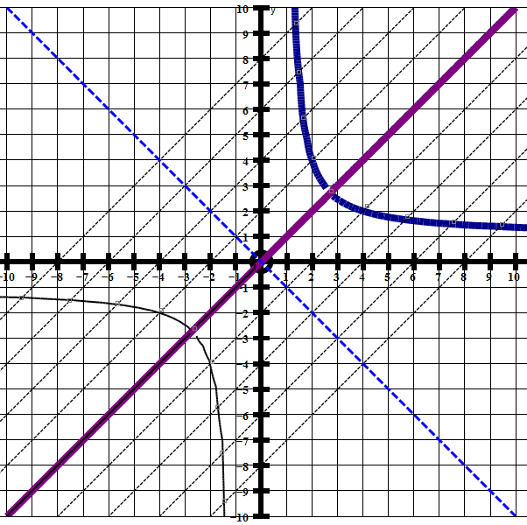
The solutions to${ x}^{y}=y^{x}$ previously known are all the points on the purple line y = x, all the points on the blue “hyperbola-like curve” and all the points denoted by red dots ( )

